Delhi Metro Optimisation Report

# Introduction

The Delhi Metro system is one of the largest metro networks in the world, serving millions of passengers daily. Despite its vast coverage, there are significant challenges such as overcrowding during peak hours, inefficient service distribution, and issues related to last-mile connectivity. This report aims to optimize metro operations using GTFS data and propose data-backed operational improvements.

# Dataset Overview

The dataset provided includes several files from the GTFS (General Transit Feed Specification) format. **Key datasets** include:

1. trips.txt: Contains information on trips including route and service details.  
2. stop_times.txt: Provides stop-specific details such as arrival and departure times.  
3. stops.txt: Lists metro stations with geographic coordinates.  
4. shapes.txt: Describes the paths/routes of each trip.  
5. routes.txt: Details of each route including type and description.  
6. calendar.txt: Describes service schedules.  
7. agency.txt: Information about the metro agency.

# Geographical Distribution of Metro Stops

The following graph shows the Geographical Distribution of Metro Stops.

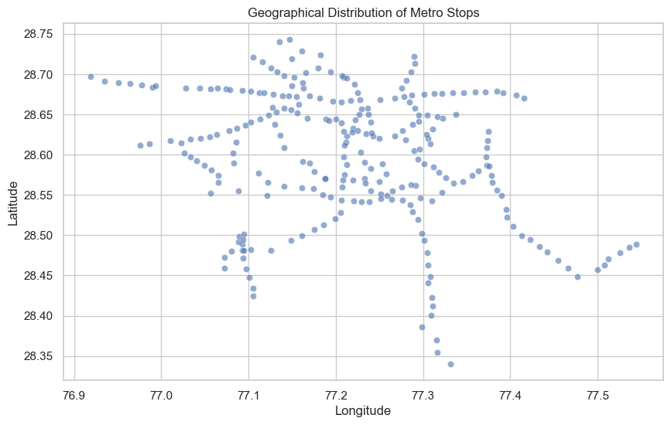

## Top 10 Stops by Number of Trips

The following bar plot shows the top 10 stops with the highest number of trips, indicating areas with likely congestion.

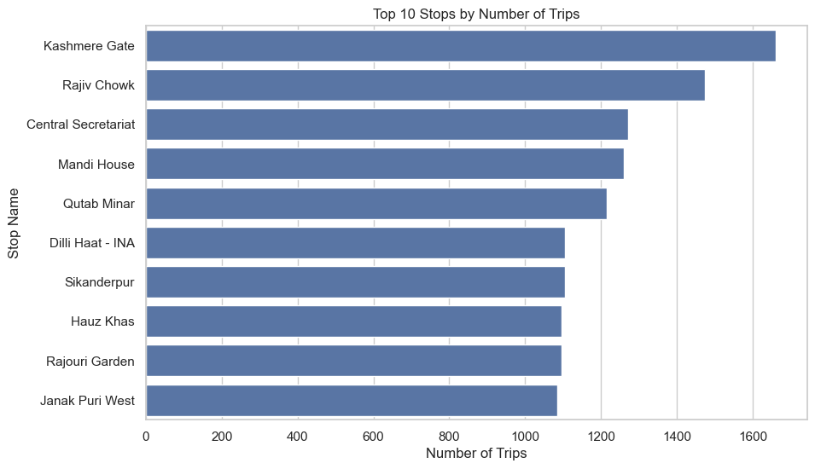

# Distribution of trips by hours per day

The following chart shows distribution of trips by hours per day.

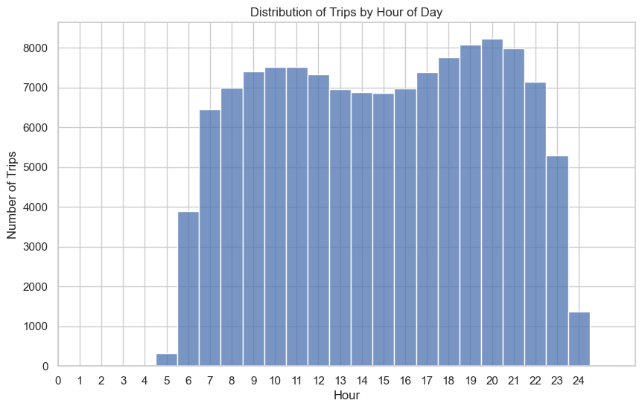

## Trips Frequency by Hour

The following line plot shows the distribution of trips across different hours of the day. Peak hours are evident, showing periods where overcrowding might occur.

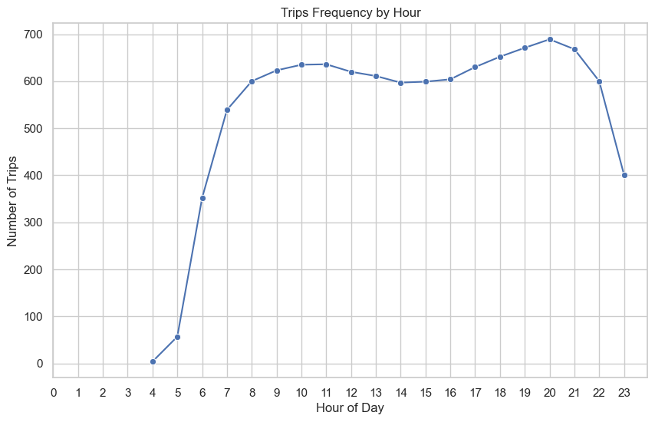

## Top 10 Routes by Number of Trips

The bar plot below presents the top 10 routes based on the number of trips. These routes are well-served, while other routes might be under-served.

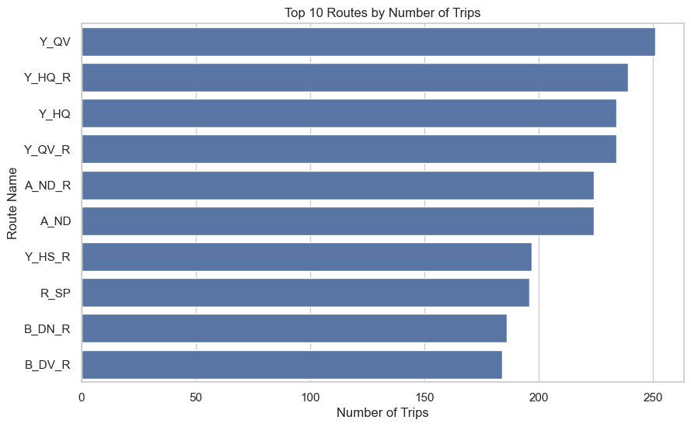

# Suggestions to Optimize Delhi Metro

After going through the data, we found a few important ways to make the Delhi Metro run better for everyone:

1. **Run more trains during rush hours** – Some stations and routes get super crowded in the mornings and evenings. Adding more trains at these times can help reduce the crowd and make the journey more comfortable.
2. **Send more trains to less-used routes** – Some parts of the city don’t get as many trains as others. By adjusting the schedule and sending more trains to those areas, we can make the metro more useful for people who don’t have good access right now.
3. **Improve last-mile travel** – Even after getting off at a metro station, many people still struggle to reach their home or office. Connecting the metro with easy options like e-rickshaws or shared autos can help make that last part of the journey smoother.

# International Practices to optimize Metro

Cities around the world have adopted innovative approaches to optimize metro systems, which can be applied to Delhi Metro:

1. **Tokyo**: Integrated metro services with private bus networks to cover last-mile connectivity and optimize traffic flows. It also Employs AI-powered passenger flow balancing by suggesting alternate routes via mobile apps.
2. **London**: Uses real-time passenger information to adjust metro frequencies based on demand, reducing overcrowding like data from **weather forecasts**, **city events**, and even **social media trends** to predict when and where crowds are likely to build up.
3. **Singapore**: Invested in smart technologies such as contactless payments and mobile apps to streamline the travel experience.

# Conclusion

The Delhi Metro network faces challenges related to overcrowding, uneven service distribution, and last-mile connectivity. By analyzing the GTFS data, we have identified key areas of improvement and suggested data-backed strategies. By learning from global best practices and adopting innovative technologies, Delhi Metro can further optimize its operations and provide a better experience for passengers.